1. Training Materials – Structure, Organization & Functionality

Issue:
- Training Materials section is not properly organized or functional
- Current setup feels static and limited
- Categories and filters are not working correctly
- Uploaded content does not appear under the correct filters
- No clear structure for scaling training (e.g., universities, modules, etc.)

Required Fixes:

1. Folder & Subfolder System
- Ability to create:
  - Main folders (e.g., “ACA University”, “Health Insurance Training”)
  - Subfolders within those folders
- Structure should work similar to:
  - Document Hub

2. Editable Categories
- Current categories (General, Leadership, Sales, etc.) should NOT be fixed
- I need the ability to:
  - Create custom categories
  - Edit existing categories
  - Delete categories

Examples:
- Health Insurance
- ACA
- Medicare
- Life Insurance
- Recruiting

3. Fully Functional Filters
- Filters must correctly display content based on type:
  - Videos
  - Documents
  - Links
  - Articles
- Current issues:
  - PDFs uploaded do not show under Documents
  - Links do not appear under Links filter
  - Videos only partially appear

👉 Fix so each file type appears correctly under its filter

4. Content Type Accuracy
- System should correctly recognize:
  - YouTube links
  - Loom links
  - PDFs
  - External links
- Each should automatically categorize into the correct filter

5. URL & File Functionality
- Ensure:
  - URLs open correctly
  - PDFs open/download correctly
- Currently:
  - Some links/files are not working

Goal:
- Create a structured, scalable training system
- Allow full control over organization
- Ensure all content displays and functions properly
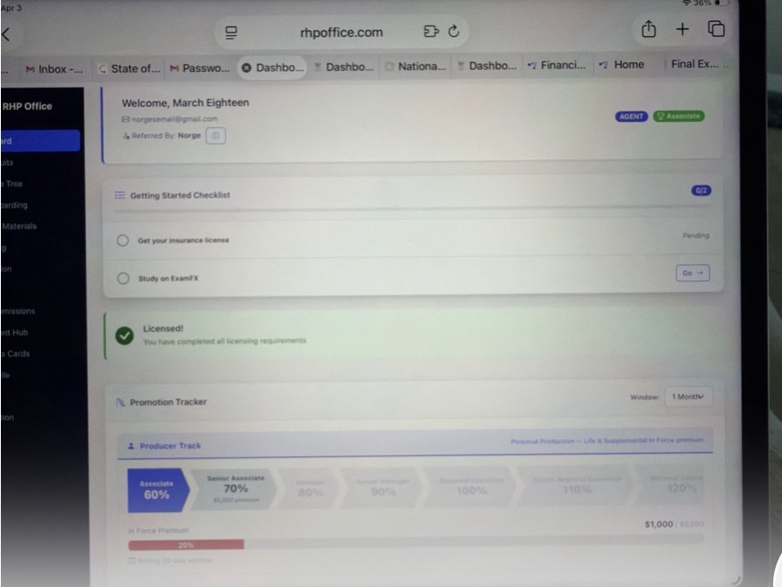
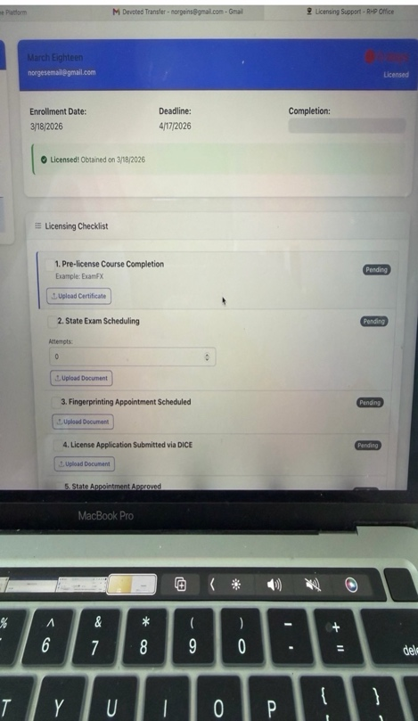
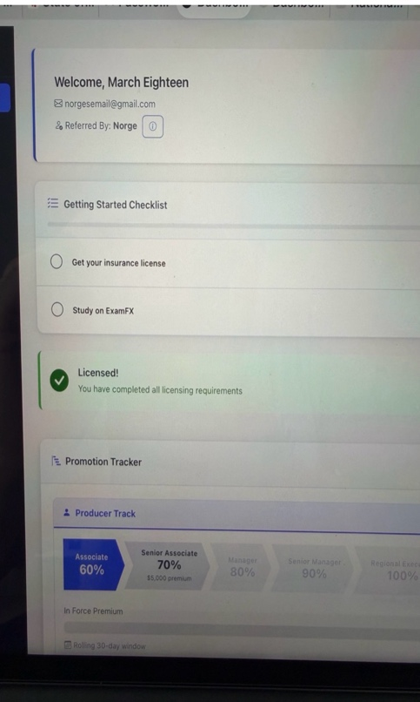

2. Training Materials – Video & Content Viewing (iPad / Mobile Fix)

Issue:
- When opening training content (especially videos like Loom) on iPad:
  - The video opens inside the screen
  - There is no way to exit or close the video
- User gets stuck and cannot return back to the training materials page
- On desktop:
  - It opens in a new tab (works fine)
- On iPad/mobile:
  - It opens embedded → no navigation / no exit

Required Fixes:

1. Add Exit / Close Option
- When content opens (video, PDF, etc.), user must have:
  - A clear “Close” or “Back” button
- User should always be able to:
  - Return to the previous screen easily

2. Improve Mobile/iPad Behavior
- Content should either:
  - Open in a new tab, OR
  - Open in a modal with a visible close button

👉 Current behavior (no exit) is not usable

3. Standardize Content Viewing
- All content types should behave consistently:
  - Loom videos
  - YouTube videos
  - PDFs
  - Links
- No matter the type:
  - User must always be able to navigate back

Goal:
- Ensure smooth navigation when viewing training materials
- Prevent users from getting stuck inside content
- Make mobile/iPad experience fully functional

3. Carrier Management – Agent View Not Syncing with Admin

Issue:
- Information entered on the admin side (Carrier Management) is not reflecting on the agent side
- On the agent side, only:
  - Commission factors are visible
- The following fields are NOT showing to agents:
  - Contracting Link
  - Contracting Instructions
  - What to Expect
  - Notes

👉 This makes the section incomplete and not useful for agents

Required Fixes:

1. Sync Admin → Agent View
- All fields entered in Carrier Management must display on agent side:
  - Contracting Link (clickable)
  - Contracting Instructions
  - What to Expect
  - Notes

2. Agent View Layout
- When agent clicks “View Details”:
  - Show full carrier information
  - Not just commission factors

3. Make It Usable for Agents
- Agents should be able to:
  - See full instructions
  - Access contracting links directly
  - Understand what to expect without asking admin

Goal:
- Turn Carrier section into a self-serve contracting hub
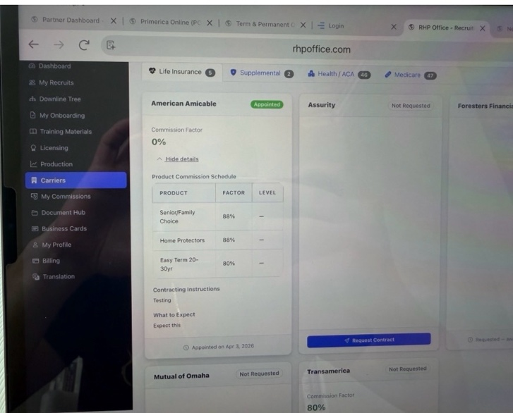
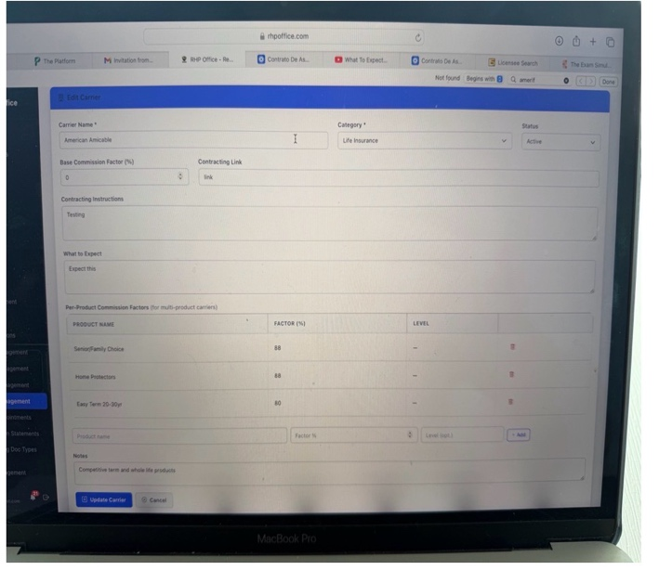
- Ensure all admin-entered information is visible and usable on the agent side

4. Carrier Management – Contract Request Notifications & Control

Issue:
- When an agent requests a carrier contract:
  - There is no notification sent to admin
- Requests only appear inside the system
- Admin has to manually check instead of being alerted
- In Carrier Appointments:
  - Admin can appoint, but cannot unappoint (no undo option)
- No proper tracking or communication:
  - No notes section
  - No timestamp of actions

Required Fixes:

1. Contract Request Notifications
- When an agent requests a contract:
  - Admin should receive a notification
- This should appear in:
  - Notification system (bottom left)

2. Appoint / Unappoint Control
- Allow admin to:
  - Appoint
  - Unappoint (reverse action if needed)

👉 Mistakes need to be fixable

3. Notes Section
- Add ability to:
  - Leave notes per request

Examples:
- “Sent email to agent”
- “Waiting on carrier approval”

4. Timestamp Tracking
- Notes should automatically include:
  - Date
  - Time

Goal:
- Improve visibility and control over carrier contracting
- Reduce manual follow-up
- Allow admin to manage and track contract requests efficiently

5. ACA Management – Upload, Tracking, and Bonus System

Issue:

File Upload Limitations
- Only allows CSV upload (no Excel support)
- Cannot upload multiple files at once
- Must combine files manually before uploading
- No option to:
  - Delete uploaded file/batch
  - Replace incorrect upload
  - Fix mistakes after upload
- Download Sample CSV does not work

Formatting Issues
- Batch period format shows as YYYY-MM
- Should be MM-YYYY

Upload Clarity / Data Issues
- Upload history is confusing:
  - Not clear how many files were uploaded
  - Totals (clients, agents) are unclear
  - Hard to understand what data belongs to each batch
- No clear breakdown of:
  - Clients per upload
  - Agents per upload
  - Monthly totals

Monthly Data Handling
- ACA is tracked monthly, but:
  - No clear logic for replacing previous month data
  - Old data can mix with new uploads incorrectly

Error Handling
- Validation exists but is unclear
- Need better visibility for:
  - Unmatched agents
  - Upload errors
  - Row-level issues

Team Tracking & Bonus Logic Issues
- System does NOT properly reflect:
  - Team client totals
  - Upline accumulation
- No separation between:
  - Personal clients
  - Team clients
- Bonus tier tracking is incomplete:
  - Does not clearly reflect total (personal + team)
- No visibility into:
  - Which agents contributed how many clients

Tier Management Issues
- Tiers are fixed and cannot be edited
- Cannot:
  - Change thresholds (ex: 1000 → 1500)
  - Change bonus amounts
- Cannot assign:
  - Different tiers per agent
- Admin cannot see:
  - What tier each agent is currently in

Required Fixes:

1. File Upload Improvements
- Allow upload of:
  - CSV
  - Excel files (.xlsx, .xls)
- Allow multiple file uploads at once

2. File Management
- Allow admin to:
  - Delete uploaded batch
  - Replace incorrect uploads
  - Re-upload corrected files

3. Sample File
- Fix Download Sample CSV

4. Batch Period
- Change format to MM-YYYY
- Tie uploads clearly to a specific month

5. Upload History / Clarity
- Show:
  - Number of files uploaded
  - Totals per batch
  - Clear separation by month

6. Monthly Data Logic
- Each month tracked independently
- No mixing of previous data
- Allow overwrite/update

7. Error Handling
- Show:
  - Row-level errors
  - Unmatched agents
  - Clear reasons for failures

8. Personal vs Team Tracking
- Add:
  - Personal clients / personal verified clients
  - Team clients / team verified clients
- Ensure totals reflect:
  - Personal + Team combined

9. Bonus Tier Tracking
- Progress should reflect:
  - Total clients (personal + team)

10. Team Breakdown
- Add expandable section showing:
  - Agent name
  - Number of clients per agent

11. Tier Configuration
- Admin can:
  - Edit tier thresholds
  - Edit bonus amounts
- Allow:
  - Custom tier per agent

12. Tier Visibility
- Admin should see:
  - Current tier per agent
  - Total clients tied to that tier

Goal:
- Make ACA Management:
  - Flexible
  - Accurate
  - Easy to use
  - Aligned with your bonus structure

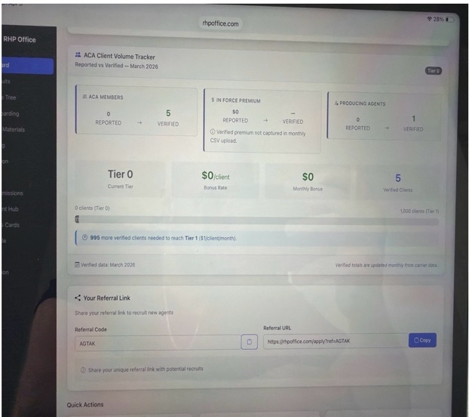
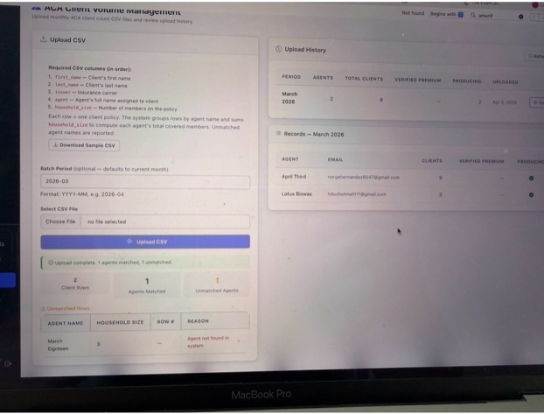
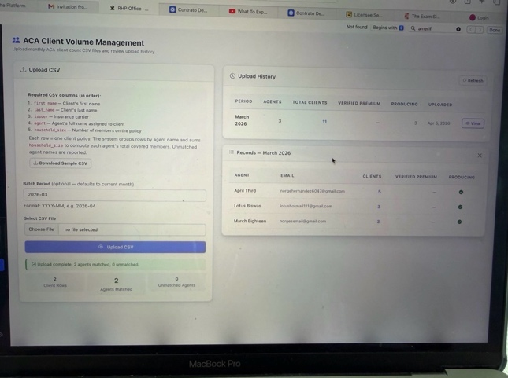
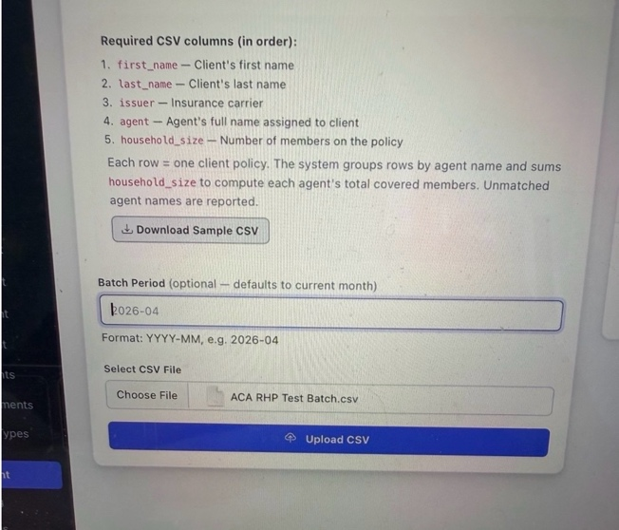

6. Commission Statements – Upload, Notes & Functionality

Issue:
- Uploading commission statements is not working properly
- System does not reliably allow:
  - Upload of files (PDFs, etc.)
- Current structure requires:
  - Selecting a carrier name, which does not make sense
  - Commission statements are typically weekly across multiple carriers, not one per carrier
- No ability to:
  - Add notes for a commission statement
- No search or efficiency tools when selecting agent names (problematic when list grows)

Required Fixes:

1. Fix File Upload
- Ensure commission statements can be:
  - Uploaded successfully
  - Accept common formats (PDF, etc.)

2. Adjust Carrier Field
- Replace:
  - “Carrier Name” (single selection)

With either:
- Multiple carriers field, OR
- Remove requirement entirely

👉 Commission statements should not require one carrier

3. Add Notes Section
- Add a field to:
  - Leave notes for each commission statement

Examples:
- “Includes adjustments from prior week”
- “Missing XYZ carrier”

4. Improve Agent Selection
- Add:
  - Search bar when selecting agent

👉 Necessary when there are many agents

5. File Handling Improvement
- When uploading a file:
  - Allow ability to remove/delete selected file before submission

👉 Currently:
- Once selected, cannot easily remove

Goal:
- Make commission uploads:
  - Functional
  - Flexible
  - Efficient as team grows
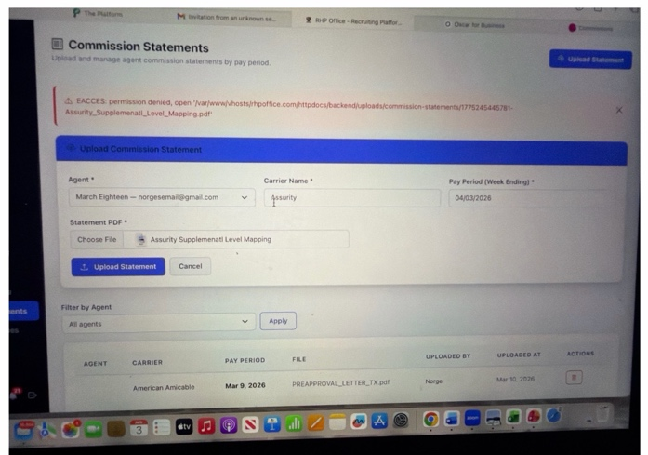

7. Business Cards – Setup

Issue:
- Business Cards feature is not set up

Required Fix:
- Set up Business Cards so agents can:
  - Access them
  - Generate them properly

Goal:
- Ensure Business Cards feature is functional and usable

8. Production – Tracking, Visibility, Filters & Ranking

Issue:

1. Missing Fields
- No field for:
  - Number of members (for ACA policies)

2. Limited Admin Control
- Current Production Management only allows:
  - Adding products
- Cannot:
  - Customize production fields
  - Add new fields or categories

3. Visibility Issues
- Upline cannot properly see:
  - Downline production
  - Who submitted each entry
- Downline production is not:
  - Reflecting correctly in upline view
  - Showing properly in builder track/dashboard

4. Notes Not Easily Viewable
- Notes require clicking “edit” to view
- Should be visible directly

5. Filters Missing
- No ability to filter production by:
  - Last 30 / 60 / 90 days
  - 6 months
  - 12 months
  - Specific month or custom date range

6. Team Tracking Not Working
- Team production is not showing correctly
- “Team report” feature is not working

7. Ranking / Sorting Missing
- No ability to:
  - Sort agents by production volume

Required Fixes:

1. Add ACA Member Field
- Add field:
  - Number of members when ACA is selected

2. Expand Production Management
- Allow admin to:
  - Customize production fields
  - Add new categories/fields

3. Fix Visibility
- Upline must be able to:
  - See all downline production
  - See who submitted each entry
- Ensure:
  - Production reflects correctly across system

4. Improve Notes Display
- Notes should be:
  - Viewable without editing

5. Add Filters
- Add filters for:
  - Last 30 / 60 / 90 days
  - 6 months
  - 12 months
  - Custom date range
  - Specific month

6. Fix Team Production
- Ensure:
  - Team production displays correctly
  - Team report works

7. Add Ranking (Admin Use)
- Allow sorting by:
  - Production volume
- Metrics:
  - Premium
  - Policies
  - ACA members

Goal:
- Make production:
  - Fully trackable
  - Visible across hierarchy
  - Easy to filter and analyze

9. Commission Statements – Upload & Functionality

Issue:
- Commission statement upload is not working properly
- System is not allowing uploads consistently
- Currently requires selecting a single carrier, which does not make sense
  - Commission statements are weekly and include multiple carriers
- No ability to:
  - Add notes to a commission statement
- No search when selecting agent
  - Difficult when there are many agents
- Cannot remove a selected file before uploading

Required Fixes:
- Fix file upload so commission statements can be uploaded properly
- Add ability to:
  - Select multiple carriers for a commission statement
- Add a notes section for commission statements
- Add a search bar when selecting agent
- Allow user to:
  - Remove/delete selected file before uploading

Goal:
- Make commission statement uploads functional and usable

10. Document Hub – Structure & Organization

Issue:
- Document Hub is currently being used for items that belong in onboarding
- It includes:
  - APA
  - E&O Insurance
  - CMS Certificate
  - W-9
  - Direct Deposit
  - AHIP / Medicare

👉 These should NOT be in Document Hub
- Document Hub feels confusing and does not have a clear purpose
- No folder structure or organization

Required Fixes:

1. Move Onboarding Documents
- Move the following into Onboarding section:
  - APA
  - E&O Insurance
  - CMS Certificate
  - W-9
  - Direct Deposit
  - AHIP / Medicare

2. Define Document Hub Purpose
- Document Hub should be used for:
  - General documents
  - Resources
  - Files not tied to onboarding

3. Folder System
- Add ability to:
  - Create folders
  - Create subfolders
- Should function similar to:
  - File storage system

4. Admin Management
- Add Document Hub Management on admin side
- Admin should be able to:
  - Create folders
  - Organize documents
  - Control structure

5. Upload Requests (Optional Control)
- Allow admin to:
  - Request documents from agents
- Agents should be able to:
  - Upload requested files

Goal:
- Separate onboarding from document storage
- Create a clean, organized document system

11. QuickBooks Integration – W-9 & Direct Deposit

Issue:
- W-9 and Direct Deposit are currently collected inside the system
- Not connected to QuickBooks
- This creates:
  - Manual work
  - Duplicate data entry

Required Fix:
- Confirm if it’s possible to:
  - Integrate with QuickBooks
- So that:
  - W-9 and Direct Deposit information can automatically sync into QuickBooks

Goal:
- Reduce manual work
- Streamline onboarding and payment setup

12. ExamFX Integration – Licensing Tracking

Issue:
- System is not connected to ExamFX
- No visibility into where agents are in the licensing process
- Recruits and uplines cannot see:
  - Progress in ExamFX
  - Course completion status

Required Fix:
- Integrate with ExamFX
- So that:
  - Agent licensing progress can be viewed inside the system
  - Uplines can see where their recruits are in the process
- This does not need to be part of Phase 3
  - Can be worked on separately while system is already in use
- Confirm:
  - If this can be done
  - What is needed to get this started

Goal:
- Track licensing progress automatically
- Improve visibility for recruiting and training

13. Billing – Visibility & Deactivation

Issue:
- Under the agent profile:
  - It shows that the $20 was paid
- But under the admin billing section:
  - It does not show that payment
- So billing is not matching between:
  - Agent view
  - Admin view

Required Fix:
- Confirm where billing should actually show
- Confirm:
  - If deactivating a user under user management:
    - Stops the $20 monthly charge
- Also confirm:
  - What “active” status means
  - If it is tied to billing/payment

Goal:
- Make billing clear
- Make sure admin can properly see and control billing

14. Promotions – Resetting Production After Promotion

Issue:
- When an agent gets promoted:
  - Their previous production is still counting toward the next level
- This is incorrect
- Production should reset after promotion

Required Fix:
- When an agent is promoted:
  - Their production should start over from zero for the new level
- Previous production should not carry over

Goal:
- Ensure promotions are tracked correctly
- Prevent incorrect advancement due to old production

15. Promotions – Licensed Agents Requirement (Builder Track)

Issue:
- In the Builder Track:
  - It shows number of agents (e.g., “2 agents”)
- But it is unclear if:
  - It is tracking licensed agents or just total agents

Required Fix:
- Confirm that Builder Track is:
  - Tracking licensed agents only
- If it does not:
  - It should be updated to track licensed agents

Goal:
- Ensure promotions are based on:
  - Licensed agents (not just total agents)

16. Notifications – Control & Customization

Issue:
- Notification system exists, but:
  - Limited control over what notifications are received
- As the system grows:
  - There will be too many notifications
  - No way to manage or filter them

Required Fix:
- Expand notifications to include:
  - New agents
  - Production submitted
  - Policies enforced (when status changes to in-force)
  - Contract requests submitted
- Add ability to:
  - Turn notifications ON/OFF by type
- Also confirm:
  - If it is possible to add custom notification types
  - Or allow admin to choose what events they want to be notified on

Goal:
- Keep notifications useful
- Avoid overload as system scales

17. My Recruits & Downline Tree – Merge, Filters & Tracking

Issue:
- “My Recruits” only shows:
  - Direct recruits
- Cannot:
  - See full hierarchy
  - View second-level or deeper agents
- “Downline Tree” exists but:
  - Not functional
  - Cannot search
  - Not useful
- Both sections are:
  - Separate
  - Overlapping
  - Inefficient

Required Fix:

1. Combine Structure
- Merge:
  - My Recruits
  - Downline Tree
- Create one section to:
  - View
  - Search
  - Manage hierarchy

2. Full Hierarchy Visibility
- Ability to:
  - See entire team under any agent
  - Not limited to direct recruits

3. Search Function
- Add search by:
  - Agent name
  - Agent ID
- Must return:
  - Anyone in hierarchy

4. Filters (Recruiting Tracking)
- Add filters:
  - Last 30 / 60 / 90 days
  - Specific month
  - Custom date range
- Also allow filtering by:
  - Licensed vs unlicensed

5. Recruitment Tracking
- Show:
  - Who recruited each agent
  - When each agent was recruited
- Must allow:
  - Tracking by month
- Must still show:
  - Original recruiter even after transfers

6. Transfer Logic
- If an agent is moved:
  - New upline only gets credit from that date forward
  - No retroactive credit

Goal:
- Have one clean system to:
  - View full team
  - Track recruiting
  - Understand structure and growth

18. Document Hub – Management, Structure & Upload Requests

Issue:
- Document Hub does not have a clear structure
- No ability to:
  - Create folders
  - Create subfolders
- No proper way to:
  - Organize documents
- No admin section to:
  - Manage Document Hub
- No way to:
  - Request documents from agents

Required Fix:

1. Folder & Subfolder System
- Add ability to:
  - Create folders
  - Create subfolders
- Should function like:
  - A file storage system

2. Document Hub Management (Admin)
- Add a Document Hub Management section on the admin side
- Admin should be able to:
  - Create folders
  - Create subfolders
  - Organize documents

3. Upload Requests
- Add functionality for admin to:
  - Request documents from agents
- Agents should be able to:
  - Upload documents when requested

4. Purpose of Document Hub
- Document Hub should be used for:
  - General documents
  - Instructions
  - Resources for agents
- Should not be used for:
  - Onboarding checklist items

Goal:
- Create a clean and organized document system
- Allow admin to control documents and requests

19. Training Management – Structure, Folders & Functionality

Issue:
- Training Management is not organized properly
- No ability to:
  - Create folders
  - Create subfolders
- Current structure is fixed:
  - Categories like General, Leadership, Sales, etc.
  - Cannot be edited
- Filters are not working properly:
  - Content does not show under correct sections
  - Must click “All” to see everything
- Content types are not working correctly:
  - Videos, links, documents are not separating properly

Required Fix:

1. Folder & Subfolder System
- Add ability to:
  - Create folders
  - Create subfolders
- Example:
  - “ACA University”
  - “Health Insurance Training”

2. Editable Categories
- Allow admin to:
  - Edit categories
  - Create new categories
  - Remove categories

3. Fix Filters
- Ensure filters correctly display:
  - Videos
  - Documents
  - Links
  - Articles
- Each type must show correctly under its filter

4. Content Functionality
- Ensure:
  - URLs work
  - PDFs open properly
  - Videos display correctly

Goal:
- Create a structured and usable training system
- Allow full control over organization

20. Training Materials – Functionality, Editing & Filters

Issue:
- Training Materials works on agent side visually, but admin side is limited
- Cannot:
  - Organize content into folders
  - Create subfolders
- Categories are:
  - Not editable
  - Not functional
- Filters are not working:
  - Documents do not show under Documents
  - Links do not show under Links
  - Videos are inconsistent
  - Must click “All” to see everything
- Content behavior issues:
  - Some videos do not appear correctly
  - Links do not show in correct filter

Required Fix:

1. Folder & Subfolder System
- Allow admin to:
  - Create folders
  - Create subfolders
- Example:
  - “ACA University”
  - “Health Insurance Training”

2. Editable Categories
- Allow admin to:
  - Edit categories
  - Create new categories
  - Remove categories

3. Fix Filters
- Ensure filters correctly display:
  - Videos
  - Documents
  - Links
  - Articles
- Content must appear under correct filter

4. Content Functionality
- Ensure:
  - URLs work
  - PDFs open properly
  - Videos display correctly

Goal:
- Make training materials:
  - Fully functional
  - Organized
  - Easy to manage

21. Full Hierarchy – Roles, Purpose & Functionality

Issue:
- Full Hierarchy overlaps with:
  - Downline Tree
- Both sections:
  - Show similar information
  - Do not have a clear difference in purpose
- Full Hierarchy is mostly:
  - A read-only view
  - Not useful for managing anything
- Cannot:
  - Edit roles
  - Assign or remove admins
  - Manage users directly
- Confusion between:
  - Agent
  - Recruit

Required Fix:

1. Define Purpose
- Full Hierarchy should be used for:
  - Managing users
  - Managing roles
- Downline Tree should remain:
  - A view-only structure

2. Role Management
- Allow admin to:
  - Assign Admin role
  - Remove Admin role
- Allow ability to manage:
  - Admin
  - Agent
  - Recruit

3. Role Definition
- Clarify:
  - Recruit = not licensed
  - Agent = licensed
- System should:
  - Automatically update role based on licensing

4. Functionality
- Make Full Hierarchy:
  - Functional
  - Not just a duplicate view

5. Counts at the Top
- Ensure accurate tracking of:
  - Total Users
  - Admins
  - Agents
  - Recruits

Goal:
- Remove duplication between sections
- Make Full Hierarchy a usable admin tool

22. Production – Tracking, Visibility, Filters & Functionality

Issue:

1. Missing Fields
- No field for:
  - Number of members (for ACA policies)

2. Limited Control (Admin)
- Current Production Management only allows:
  - Adding products
- Cannot:
  - Customize production fields
  - Add new fields

3. Visibility Issues
- Upline cannot properly see:
  - Downline production
  - Who submitted each entry
- Downline production is not:
  - Showing under upline correctly
  - Reflecting in builder track

4. Notes Not Visible
- Notes can only be seen by clicking “edit”
- Should be visible directly

5. Filters Missing
- No ability to filter production by:
  - Last 30 / 60 / 90 days
  - Specific month
  - Custom date range

6. Team Production Issues
- Team production is not showing correctly
- “Team report” section:
  - Does not work

7. Training Production
- No way to track:
  - Production done during training

8. Dashboard Sync Issues
- When downline submits production:
  - It does not reflect properly:
    - In upline dashboard
    - In builder track

Required Fix:
- Add field for:
  - Number of members (ACA)
- Allow admin to:
  - Customize production fields
- Ensure:
  - Upline can see all downline production
  - Production reflects properly across system
- Make notes:
  - Visible without editing
- Add filters:
  - Last 30 / 60 / 90 days
  - Specific month
  - Custom date range
- Fix:
  - Team production visibility
  - Team report functionality
- Add ability to:
  - Track production during training
- Ensure:
  - Production reflects correctly in dashboards and promotions

Goal:
- Make production fully trackable
- Ensure visibility across hierarchy
- Allow accurate tracking and promotion logic

23. Applications – Approval & Rejection Notifications

Issue:
- In the application section (APA applications):
  - There is an option to approve or reject
- However:
  - It is unclear what happens after approval or rejection
  - No confirmation that:
    - An email is sent
    - The agent is notified
- Currently:
  - Rejection allows entering a reason
  - But no clear communication is sent automatically

Required Fix:
- When an application is:
  - Approved
  - Rejected
- System should:
  - Automatically send an email notification to the agent
- If rejected:
  - Include the rejection reason in the email
- Confirm if there is an option to:
  - Skip manual approval if not needed
  - Or keep approval as optional

Goal:
- Make application process clear
- Ensure agents are notified of status
- Improve communication without manual follow-up

24. Coupon Management – Applicable Roles (Question)

Question:
- In Coupon Management, there is a field for:
  - Applicable Roles (Admin / Agent)
- What does this mean?
- How does this affect:
  - Who can use the coupon
  - How the coupon is applied

25. Dashboard – Admin View (Metrics & Layout)

Issue:
- Current admin dashboard shows:
  - Producer Track
  - Builder Track
  - Getting Started Checklist
- These are:
  - Not relevant for admin
  - Should not be visible
- Dashboard does not provide:
  - Clear business metrics
  - Useful overview of activity

Required Fix:

1. Remove Unnecessary Sections
- Remove from admin dashboard:
  - Producer Track
  - Builder Track
  - Getting Started Checklist

2. Add Key Metrics (Top Section)
- Display:
  - Total Active Agents
  - Licensed Agents
  - Unlicensed Agents

3. 24-Hour Activity
- Show:
  - New agents (last 24 hours)
    - Licensed
    - Unlicensed
  - New production (last 24 hours):
    - Submitted
    - In-force

4. ACA Section
- Show:
  - Total ACA clients
- Show:
  - Top 5 agents (personal ACA clients)
  - Top 5 agents (team ACA clients)

5. Notifications / Alerts
- Add section for:
  - Contract requests
  - Important system notifications

6. Navigation
- Clicking metrics should:
  - Redirect to relevant sections (recruits, production, etc.)

Goal:
- Provide a clear overview of:
  - Team size
  - Growth
  - Production
  - ACA volume
  - Items needing attention

